POS PRINTER SDK
POS PRINTER SDK 1
1.Introduction 3
2.Version release record 4
3.Function reference 4
public static void POS_Open(string sPortName, int nComBaudrate, int nComDataBits, int nComStopBits, int nComParity, int nParam) 4
public static Boolean POS_IsOpen() 5
public static void POS_Close() 5
public static void POS_SetWriteTimeout(int timeout) 5
public static void POS_SetReadTimeout(int timeout) 5
public static void POS_Write(byte[] buffer) 6
public static void POS_Read(byte[] buffer) 6
public static void POS_Reset() 6
public static void POS_SetMode(int nPrintMode) 6
public static void POS_SetMotionUnit(int nHorizontalMU, int nVerticalMu) 7
public static void POS_SetCharSetAndCodePage(int nCharSet, int nCodePage) 7
public static void POS_FeedLine() 9
public static void POS_SetLineSpacing(int nDistance) 9
public static void POS_SetRightSpacing(int nDistance) 9
public static void POS_CutPaper(int nMode, int nDistance) 10
public static void POS_RTQueryStatus(byte[] buffer) 11
public static void POS_S_SetAreaWidth(int nWidth) 13
public static void POS_S_TextOut(string pszString, int nOrgx, int nWidthTimes, int nHeightTimes, int nFontType, int nFontStyle) 13
public static void POS_S_SetBarcode(string pszInfoBuffer, int nOrgx, int nType, int nWidthX, int nHeight, int nHriFontType, int nHriFontPosition) 15
public static void POS_PrintBitmap(Bitmap orgBitmap) 17
public static void POS_PL_SetArea(int nOrgx, int nOrgy, int nWidth, int nHeight, int nDirection) 18
public static void POS_PL_TextOut(string pszString, int nOrgx, int nOrgy, int nWidthTimes, int nHeightTimes, int nFontType, int nFontStyle) 19
public static void POS_PL_SetBarcode(string pszInfoBuffer, int nOrgx, int nOrgy, int nType, int nWidthX, int nHeight, int nHriFontType, int nHriFontPosition) 21
public static void POS_PL_Print() 23
public static void POS_PL_Clear() 24
4. Appendix ………………………………………………………………………………………………………..24
Appendix A Printer supplementary instruction 24
Appendix B Barcode instruction…………………………………………………………………………..26
Appendix C USB interface instruction 32

1.Introduction
SerialPosLib.dll is a C# dynamic depot based on vs2005, to conveniently directly control the printer by program. Its functions mainly include the following 3 parts:
1．General function
This function supports printer’s 3 types printing modes simultaneously (standard mode, page mode, label mode).

POS_Open | Open the interface, then set up the tele-communication with printer
POS_Close | Close the interface，disconnect with printer
POS_Reset | Reset the printer
POS_SetMode | Set the printing mode and paper out model
POS_SetMotionUnit | Set the motion unit of printer
POS_SetCharSetAndCodePage | Set Character sets and codepage
POS_FeedLine | Set linefeed
POS_SetLineSpacing | Set line spacing
POS_SetRightSpacing | Set right spacing
POS_QueryStatus | Query status
POS_RTQueryStatus | RT query status
POS_KickOutDrawer | Kick out drawer
POS_CutPaper | Cut paper

2．Function of supporting standard printing mode (line mode) only.

POS_S_SetAreaWidth | Set area width
POS_S_TextOut | Set text out
POS_S_SetBarcode | Set barcode printing

3. Function of supporting page mode printing (P) or label mode printing (L).

POS_PL_SetArea | Set area
POS_PL_TextOut | Set text out
POS_PL_SetBarcode | Set barcode
POS_PL_Print | Printing full page or label
POS_PL_Clear | Clear page or label data buffering

2.Version release record
Version: 2.0.1
Date: 13rd August, 2013
Remark:
Official version first released.

3. Function reference

Public static void POS_Open(string sPortName, int nComBaudrate, int nComDataBits, int nComStopBits, int nComParity, int nParam)
Description:
Open the designated serial and Ethernet ports parameters:
sPortName example: "COM1","COM2"...
nComBaudrate 9600, 19200, 38400, 57600, 115200 Baudrate
nComDataBits 5,6,7,8
nComStopBits 0,1,2 successively indicates stop bit 1,1.5,2
nComParity 0,1,2,3,4 successively indicates parity bit None,Odd,Even,Mark,Space
nParam 0 indicates flow control off, “0x1” indicates DTR/RTS flow control控on.
Remarks:
Whether the ports on/off should be distinguished by POS_IsOpen(). If fail to open the ports, pleaese refer to “lasterror” to find out reasons. Only few functions request to set “lasterror”.
This function can be for open Ethernet port and USB port as well, but only one of these two work at a time. Which port to work depending on “nParam”, if “nParam” says “0 or 1”，then “sPortName” means serial port, example “com1，com2” etc. If “nParam” says “2”, then “sPortName” means Ethernet port, example “192.168.0.67” etc. If “nParam” says “3”，then means printing to driver port, example “RP80 Printer” etc.

Public static Boolean POS_IsOpen()
Description:
Port to be opened or not.

Public static void POS_Close()
Description:
Close the ports already on.

Public static void POS_SetWriteTimeout(int timeout)
Description:
Set input-timeout for serial port, null for USB port.
Parameter:
timeout millisecond.

Public static void POS_SetReadTimeout(int timeout)
Description:
Set read timeout for serial port, null to USB port.
Parameter:
timeout millisecond.

Public static void POS_Write(byte[] buffer)
Description:
If serial port already on, then data of buffer will be sent out to serial port.
Parameter:
buffer byte array needed to be sent out.

Public static void POS_Read(byte[] buffer)
Description:
If serial port opened /on, then data will be read from serial port to fill buffer, null to USB port.
Parameter:
buffer receives data buffering area.

Public static void POS_Reset()
Description:

Reset printer to clear the printing buffer data, and the on setting of character and line spacing. Then printing mode restores to the default mode.

Public static void POS_SetMode(int nPrintMode)
Description:
Set the printing mode.
Parameter:
nPrintMode
[in] designates to printing mode.
Following values available:

Flag | Value | Meaning
POS_PRINT_MODE_STANDARD | 0x00 | Standard mode (Line mode)
POS_PRINT_MODE_PAGE | 0x01 | Page mode
POS_PRINT_MODE_BLACK_MARK_LABEL | 0x02 | Black mark label mode

Public static void POS_SetMotionUnit(int nHorizontalMU, int nVerticalMu)
Description:
Set printer’s motion unit.

Parameter:

nHorizontalMU
[in] set horizonal motion unit to be 25.4 / nHorizontalMU millimeter, 0~255 available.
nVerticalMU
[in] set vertical motion unit to be 25.4 / nVerticalMU millimeter, 0~255 available.

Public static void POS_SetCharSetAndCodePage(int nCharSet, int nCodePage)
Description:

Select the character sets and codepage.

Parameter:
nCharSet
[in] designates character sets. Different character sets have different definitions for ASCII value of “0x23~0x7E”.
Following values available:

Value | Meaning
0x00 | U.S.A
0x01 | France
0x02 | Germany
0x03 | U.K.
0x04 | Denmark I
0x05 | Sweden
0x06 | Italy
0x07 | Spain I
0x08 | Japan
0x09 | Nonway
0x0A | Denmark II
0x0B | Spain II
0x0C | Latin America
0x0D | Korea

nCodePage
[in] designates character’s codepage. Different codepages have different definition for ASCII value of “0x80~0xFF”, please refer to printer’s self-testing.

Public static void POS_FeedLine()
Description:

Paper forward.

Public static void POS_SetLineSpacing(int nDistance)
Description:

Set character’s line spacing.

Parameter:

nDistance
[in] Designates line spacing dot value.
0~255 available, distance of every dot concerns to printing head’s resolution.

Public static void POS_SetRightSpacing(int nDistance)
Description:

Set character’s right spacing (distance of every near character)

Parameter:

nDistance
[in] designates right spacing dot value.
0~255 available, distance of every dot concerns to printing head’s resolution.

public static void POS_KickOutDrawer(int nID, int nOnTimes, int nOffTimes)
To be confirmed.

Public static void POS_CutPaper(int nMode, int nDistance)
Description:

Cut paper.

Parameter:
nMode
[in] Designates the paper cutting mode.
Following values available:

Flag | Value | Meaning
POS_CUT_MODE_FULL | 0x00 | Full cut
POS_CUT_MODE_PARTIAL | 0x01 | Semi cut

nDistance
[in] Designates the dots of paper-in length.
0~255 available, distance of every dot concerns to printing head’s resolution.

Remarks:

1．If designated to be full cut mode, then ignore the parameter “nDistance”.

- If designated to be semi cut mode, then paper slips “nDistance” dots to cut.

Public static void POS_RTQueryStatus(byte[] buffer)
Description:
Transfer printer status on real time.
Parameter:
buffer receives buffering data area, 4 bytes.

Remarks:
Printer returns to relate status, when receives this command.
Please try not to insert this command into command array with 2 or more bytes.
Printer will do this command immediately when it receives, even though it is doing printing.
Printer will return when gets this command, whatever status it stays.
Return values defined as below:
n=1 correspond buffer[0]
n=2correspond buffer[1]
…
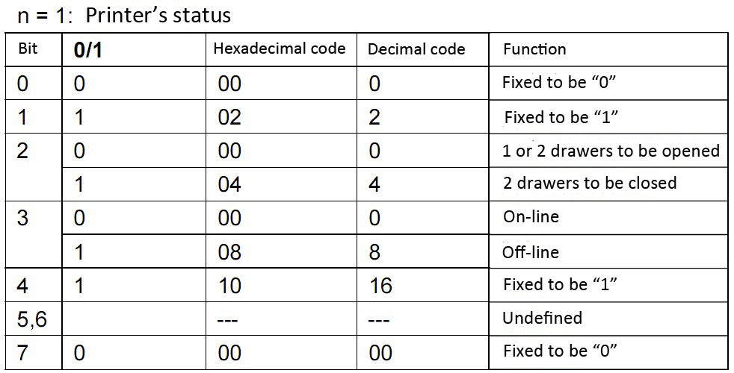
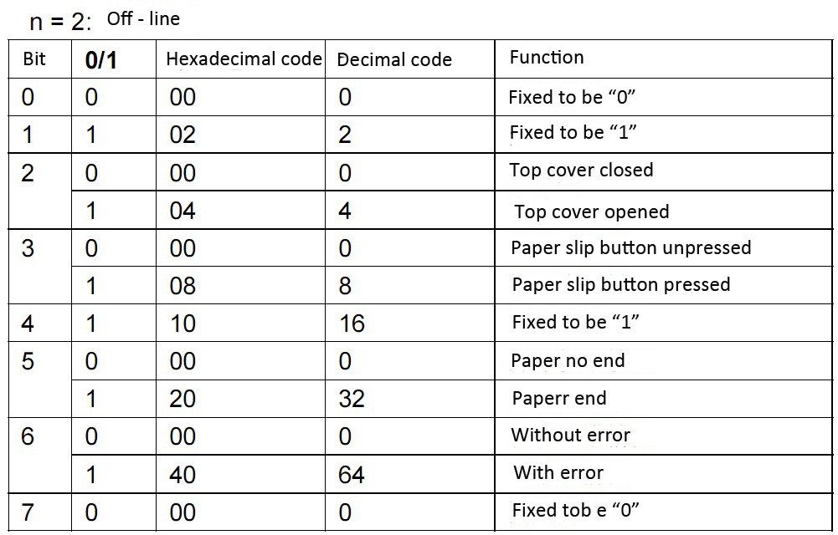
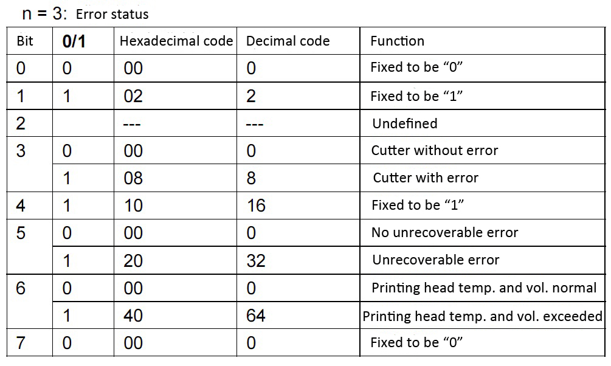
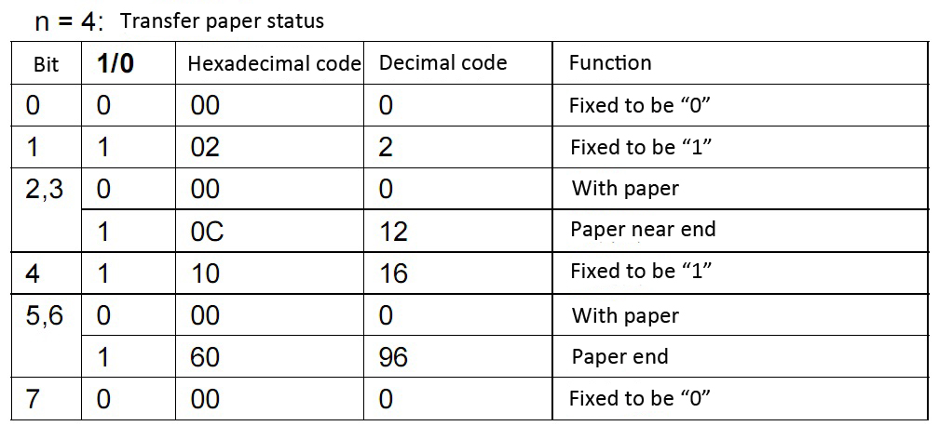

Public static void POS_S_SetAreaWidth(int nWidth)
Description:

Set the printing width under standard printing mode.

Parameter:

nWidth
[in] Designates the width of printing
0~65535 dots available, but printing width should not exceed 576 limited to the paper width.

Public static void POS_S_TextOut(string pszString, int nOrgx, int nWidthTimes, int nHeightTimes, int nFontType, int nFontStyle)
Description:

Transfer the character string needed to be printed to buffer area, and given an absolute starting position in X direction (horizon), designates enlarge percentage, types and style for every character in the width and height.

Parameter:

pszString
[in] the character string needed to be printed.

nOrgx
[in] Designates the starting position dot from the left edge.
0~65535 available.

nWidthTimes
[in] Designates the enlarge percentage of character in width.
0~7 available.

nHeightTimes
[in] Designates the enlarge percentage of character in height.
0~7 available.

nFontType
[in] Designates the font type for character.
Following values available:

Flag | Value | Meaning
POS_FONT_TYPE_STANDARD | 0x00 | Standard ASCII
POS_FONT_TYPE_COMPRESSED | 0x01 | Compressed ASCII

nFontStyle
[in] Designates the character font style.
One or more of following values available:

Flag | Value | Meaning
POS_FONT_STYLE_NORMAL | 0x00 | Normal
POS_FONT_STYLE_BOLD | 0x08 | Bold
POS_FONT_STYLE_THIN_UNDERLINE | 0x80 | 1 dot underline
POS_FONT_STYLE_THICK_UNDERLINE | 0x100 | 2 dots underline
POS_FONT_STYLE_UPSIDEDOWN | 0x200 | Upright (First line valid)
POS_FONT_STYLE_REVERSE | 0x400 | Reverse (black& white character)
POS_FONT_STYLE_CLOCKWISE_90 | 0x1000 | 90 degree in clockwise direction

Public static void POS_S_SetBarcode(string pszInfoBuffer, int nOrgx, int nType, int nWidthX, int nHeight, int nHriFontType, int nHriFontPosition)
Description:

Set and print label.

Parameter:

pszInfoBuffer
[in] Label character string. The allowed area and format concerns to the specific label.

nOrgx
[in] Designates the label starting position dot from the left edge.
0~65535 available.

nType
[in] Designates the label type.
Following values available, please also refer to “Appendix B Barcode instruction”.
Flag | Value | Meaning
POS_BARCODE_TYPE_UPC_A | 0x41 | UPC-A
POS_BARCODE_TYPE_UPC_E | 0x42 | UPC-C
POS_BARCODE_TYPE_JAN13 | 0x43 | JAN13(EAN13)
POS_BARCODE_TYPE_JAN8 | 0x44 | JAN8(EAN8)
POS_BARCODE_TYPE_CODE39 | 0x45 | CODE39
POS_BARCODE_TYPE_ITF | 0x46 | INTERLEAVED 2 OF 5
POS_BARCODE_TYPE_CODEBAR | 0x47 | CODEBAR
POS_BARCODE_TYPE_CODE93 | 0x48 | CODE93
POS_BARCODE_TYPE_CODE128 | 0x49 | CODE 128

nWidthX
[in] Designates the elementary width for label.
Following values (n) available:

n | Single elementary module width  （continuous） | Double elementary module width（Scatter）
n | Single elementary module width  （continuous） | Norrow elementary width | Wide elementary width
2 | 0．25mm | 0．25mm | 0．625mm
3 | 0．375mm | 0．375mm | 1．0mm
4 | 0．5mm | 0．5mm | 1．25mm
5 | 0．625mm | 0．625mm | 1．625mm
6 | 0．75mm | 0．75mm | 1．875mm

nHeight
[in] Designates the dots for label height.
1~255 available, default to be 162 dots.

nHriFontType
[in] Designates the font type for character HRI (Human Readable Interpretation).
Following values available:

Flag | Value | Meaning
POS_FONT_TYPE_STANDARD | 0x00 | Standard ASCII
POS_FONT_TYPE_COMPRESSED | 0x01 | Compressed ASCII

nHriFontPosition
[in] Designates the position for character HRI (Human Readable Interpretation).
Following values available:

Flag | Value | Meaning
POS_HRI_POSITION_NONE | 0x00 | No printing
POS_HRI_POSITION_ABOVE | 0x01 | Print above the label only
POS_HRI_POSITION_BELOW | 0x02 | Print below the label only
POS_HRI_POSITION_BOTH | 0x03 | Print both above and below the label

Public static void POS_PrintBitmap(Bitmap orgBitmap)
Description:
Print bitmap

Parameter:
orgBitmap contains the image data of Bitmap
Remarks:
Bitmap is .Net format. This function will enlarge Bitmap to be times of min. 8 pixel, for example, enlarge 575 to be 576,383 or enlarge to be 384, then transfer it to be solid color, then transfer to the commands to printer, which can be identified.

Public static void POS_PL_SetArea(int nOrgx, int nOrgy, int nWidth, int nHeight, int nDirection)
Description:
Set the page printing area.

Parameter:

nOrgx
[in] Designates given area’s starting position dot in X direction (horizon) from the left edge.
0~ 65535 available.

nOrgy
[in] Designates given area’s starting position dot in Y direction (vertical) from the top edge (current printing head position)
0~65535 available.

nWidth
[in] Designates the width for printing area (horizon direction)
0~65535。

nHeight
[in] Designates the height for printing area (vertical direction)
0~65535。

nDirection
[in] Designates the direction for printing area (original position)
Following values available:

Flag | Value | Starting Position
POS_AREA_LEFT_TO_RIGHT | 0 | Top left
POS_AREA_BOTTOM_TO_TOP | 1 | Down left
POS_AREA_RIGHT_TO_LEFT | 2 | Down right
POS_AREA_TOP_TO_BOTTOM | 3 | Top right

Public static void POS_PL_TextOut(string pszString, int nOrgx, int nOrgy, int nWidthTimes, int nHeightTimes, int nFontType, int nFontStyle)
Description:

Transfer the character string needed to be printed to buffer area, and given an absolute starting position in X direction (horizon), designates enlarge percentage, types and style for every character in the width and height.

Parameter:

pszString
[in] Character string needed to be printed.

nOrgx
[in] Designates the starting position dot in X direction (horizon) from the left edge.
0~ 65535 available.

nOrgy
[in] Designates the starting position dot in Y direction (vertical) from the top edge.
0~65535 available.

nWidthTimes
[in] Designates the enlarge percentage for the character in width.
0~7 available.

nHeightTimes
[in] Designates the enlarge percentage for the character in height.
0~7 available.

nFontType
[in] Designates the font type for character.
Following values available:

Flag | Value | Meaning
POS_FONT_TYPE_STANDARD | 0x00 | Standard ASCII
POS_FONT_TYPE_COMPRESSED | 0x01 | Compressed ASCII

nFontStyle
[in] Designates the style for character.
One or more of following values available:

Flag | Value | Meaning
POS_FONT_STYLE_NORMAL | 0x00 | Normal
POS_FONT_STYLE_BOLD | 0x08 | Bold
POS_FONT_STYLE_THIN_UNDERLINE | 0x80 | 1 dot underline
POS_FONT_STYLE_THICK_UNDERLINE | 0x100 | 2 dot underline
POS_FONT_STYLE_REVERSE | 0x400 | Reverse (black& white character)

Public static void POS_PL_SetBarcode(string pszInfoBuffer, int nOrgx, int nOrgy, int nType, int nWidthX, int nHeight, int nHriFontType, int nHriFontPosition)
Description:

Set the label/ barcode.

Parameter:

pszInfoBuffer
[in] The character string needed to be printed. The allowed area and format concerns to the specific label type.

nOrgx
[in] Designates the label starting position dot from the left edge.
0~65535 available.

nOrgy
[in] Designates the label starting position dot from the top edge.
0~65535 available.

nType
[in] Designates the label type.
Following values available, please also refer to “Appendix B Barcode instruction”.
Flag | Value | Meaning
POS_BARCODE_TYPE_UPC_A | 0x41 | UPC-A
POS_BARCODE_TYPE_UPC_E | 0x42 | UPC-C
POS_BARCODE_TYPE_JAN13 | 0x43 | JAN13(EAN13)
POS_BARCODE_TYPE_JAN8 | 0x44 | JAN8(EAN8)
POS_BARCODE_TYPE_CODE39 | 0x45 | CODE39
POS_BARCODE_TYPE_ITF | 0x46 | INTERLEAVED 2 OF 5
POS_BARCODE_TYPE_CODEBAR | 0x47 | CODEBAR
POS_BARCODE_TYPE_CODE93 | 0x48 | 25
POS_BARCODE_TYPE_CODE128 | 0x49 | CODE 128

nWidthX
[in] Designates the elementary width for label.
Following values (n) available:

n | Single elementary module width  （continuous） | Double elementary module width（Scatter）
n | Single elementary module width  （continuous） | Norrow elementary width | Wide elementary width
2 | 0．25mm | 0．25mm | 0．625mm
3 | 0．375mm | 0．375mm | 1．0mm
4 | 0．5mm | 0．5mm | 1．25mm
5 | 0．625mm | 0．625mm | 1．625mm
6 | 0．75mm | 0．75mm | 1．875mm

nHeight
[in] Designates the dots for label height.
1~255 available.

nHriFontType
[in] Designates the font type for character HRI (Human Readable Interpretation).
Following values available:

Flag | Value | Meaning
POS_FONT_TYPE_STANDARD | 0x00 | Standard ASCII
POS_FONT_TYPE_COMPRESSED | 0x01 | Compressed ASCII

nHriFontPosition
[in] Designates the character position for HRI (Human Readable Interpretation).
Following values available:

Flag | Value | Meaning
POS_HRI_POSITION_NONE | 0x00 | No printing
POS_HRI_POSITION_ABOVE | 0x01 | Print above label only
POS_HRI_POSITION_BELOW | 0x02 | Print below label only
POS_HRI_POSITION_BOTH | 0x03 | Print both above and below label

Public static void POS_PL_Print()
Description:

Buffer data of printing page or label.

Remarks:

1．If function works, paper in to print content, but the buffer data of page or label will be reserved. This function can be referred to print continuously.

Public static void POS_PL_Clear()
Description:

Clear the buffer data of printing page and label content.

Appendix

Appendix A Printer supplementary instruction
A．1. Printing mode

Generally, printer works under standard mode and page mode only.

Under standard mode, as long as the printer receives line printing or paper-in command, it will do as command.
For example, when refer to function “POS_S_TextOut” and send character“ABCDEF”, printer will do the character string accord with function then store in buffer area, waiting for printing. When refer to function “POS_FeedLine”, paper feeds and the character string will be printed out. However, if the length exceeds the length of received buffering area, printer will feed paper and print automatically.

Under page mode, printer will store all the received processed data to page buffer area without printing. When refers to function “POS_PL_Print”, it will feed paper and print.
For example, when refer to function “POS_PL_TextOut” and send character string “ABCDEF”, printer will do the character string accord with function then store in buffer area, waiting for printing, if further refers to function “POS_FeedLine”, printer will locate the printing position to the next line head. If refers to function “ POS_PL_Print”, printer will feed paper and print out the data stored in buffer.
Under these two printing modes, data in buffer area will not be cleared automatically. If under page mode, data can be cleared by function “POS_PL_Clear”.

In addition, there is another printing mode call “label mode”, it includes black mark label mode and white mark label mode. Label mode’s printing principle can be refer to page mode.

A．2 Setting printing area

1． Printing area is set by function “POS_PL_SetArea”. If paper feeding and printing commands are finished before referring this function, printer will print content at left side (x0，y0). Width of rectangle printing area (dx dot) expands at Dx (vertical at paper in) to right side; Height expand down at Y direction (paper in direction). If no refer to this function to set printing area, then printing area will be defaulted.

2． After the printer’s printing area and printing area direction are set up by POS_PL_S etArea), its character, bitmap or down-left label in the printing area will be served as base point.
The downloaded bitmap in printing data and label data take the current location as its down-left, aligning with baseline.

- Before receiving a command including paper-in, if the printing data is already over the printing area (containing character spacing), then printer will auto paper-in forward 1 line (the length paper-in depends on the line-height set by POS_SetLineSpacing) and printing position locates to next line head.

4． The default line-height is 1/6 inch, if the vertical resolution is 203DPI, then approximately to be 34 dots. If the printing characters overlap with the last lines’, caused by: next line containing enlarged characters over 2 times in vertical, or bitmap occupies 2 lines even more, label is higher than normal character and the amount of printer’s paper feeding cannot meet, then by adding line-height will avoid this matter.

Appendix B Barcode instruction

B．1 Barcode types

Barcode types | Allowed length | Character sets
UPC-A | 11 ≤ n ≤ 12 | 48 ≤ d ≤ 57
UPC-E | 11 ≤ n ≤ 12 | 48 ≤ d ≤ 57
JAN13 (EAN13) | 12 ≤n ≤ 13 | 48 ≤ d ≤ 57
JAN 8 (EAN8) | 7 ≤n ≤ 8 | 48 ≤ d ≤ 57
CODE39 | 1 ≤ n ≤ 255 | 45 ≤ d ≤ 57, 65 ≤ d ≤ 90, 32, 36, 37,43  d1 = dk = 42
ITF | 1 ≤ n≤ 255 | 48 ≤ d ≤ 57
CODABAR | 1 ≤ n≤ 255 | 48 ≤ d ≤ 57 65 ≤ d ≤ 68, 36, 43,45,46,47 58
CODE93 | 1 ≤ n≤ 255 | 0 ≤ d ≤ 127
CODE128 | 2 ≤ n≤ 255 | 0 ≤ d ≤ 127

B．2．1 128-code summary
128 code enciphers 128 ASCII characters and 100 numbers from 00 to 99, even some special characters used by characters A, B and C, the character encode by each of characters as following:
Characters A: ASCII character 00H to 5FH
Character B: ASCII character 20H to 7FH
Character C: the 100 numbers from 00-99

128-code also can encode the following special character:
SHIFT character
“SHIFT” enable to change barcode code in the first character A to B, or from B to A, it also can back to used characters under using SHIFT from the second character.
“SHIFT”character only can exchange between character A and B, it cannot function the current code character back to input or output characters C.

Character choice by character sets （CODE A、CODE B、 CODE C）
These characters can exchange the back code character to characters A, B and C.

The functional character（FNC1、 FNC2、FNC3、FNC4）

The usage for these functional characters depends on the applied software. In characters C, only FNC1 can be used.

B．2．1 128-code character sets
Character sets A
Character | Sending data |  | Character | Sending data |  | Character | Sending data
Character | Hex | Decimal | Character | Hex | Decimal | Character | Hex | Decimal
NULL  SOH  STX  ETX  EOT  ENQ  ACK  BEL  BS  HT  LF  VT  FF  CR  SO  SI  DLE  DC1  DC2  DC3  DC4  NAK  SYN  ETB  CAN  EM  SUB  ESC  FS  GS  RS  US  SP  !  "  #  $  %  &  ' | 00  01  02  03  04  05  06  07  08  09  0A  0B  0C  0D  0E  0F  10  11  12  13  14  15  16  17  18  19  1A  1B  1C  1D  1E  1F  20  21  22  23  24  25  26  27 | 0  1  2  3  4  5  6  7  8  9  10  11  12  13  14  15  16  17  18  19  20  21  22  23  24  25  26  27  28  29  30  31  32  33  34  35  36  37  38  39 | (  )  *  +  ,  -  .  /  0  1  2  3  4  5  6  7  8  9  :  ;  <  =  >  ?  @  A  B  C  D  E  F  G  H  I  J  K  L  M  N  O | 28  29  2A  2B  2C  2D  2E  2F  30  31  32  33  34  35  36  37  38  39  3A  3B  3C  3D  3E  3F  40  41  42  43  44  45  46  47  48  49  4A  4B  4C  4D  4E  4F | 40  41  42  43  44  45  46  47  48  49  50  51  52  53  54  55  56  57  58  59  60  61  62  63  64  65  66  67  68  69  70  71  72  73  74  75  76  77  78  79 | P  Q  R  S  T  U  V  W  X  Y  Z  [  \  ]  ^  _  FNC1  FNC2  FNC3  FNC4  SHIFT  CODEB  CODEC | 50  51  52  53  54  55  56  57  58  59  5A  5B  5C  5D  5E  5F  7B,31  7B,32  7B,33  7B,34  7B,53  7B,42  7B,43 | 80  81  82  83  84  85  86  87  88  89  90  91  92  93  94  95  123,49  123,50  123,51  123,52  123,83  123,66  123,67

Character sets B
Character | Sending data |  | Character | Sending data |  | Character | Sending data
Character | Hex | Decimal | Character | Hex | Decimal | Character | Hex | Decimal
SP  !  "  #  $  %  &  '  (  )  *  +  ,  -  .  /  0  1  2  3  4  5  6  7  8  9  :  ;  <  =  >  ?  @  A  B  C  D  E  F  G | 20  21  22  23  24  25  26  27  28  29  2A  2B  2C  2D  2E  2F  30  31  32  33  34  35  36  37  38  39  3A  3B  3C  3D  3E  3F  40  41  42  43  44  45  46  47 | 32  33  34  35  36  37  38  39  40  41  42  43  44  45  46  47  48  49  50  51  52  53  54  55  56  57  58  59  60  61  62  63  64  65  66  67  68  69  70  71 | H  I  J  K  L  M  N  O  P  Q  R  S  T  U  V  W  X  Y  Z  [  \  ]  ^  _  `  a  b  c  d  e  f  g  h  i  j  k  l  m  n  o | 48  49  4A  4B  4C  4D  4E  4F  50  51  52  53  54  55  56  57  58  59  5A  5B  5C  5D  5E  5F  60  61  62  63  64  65  66  67  68  69  6A  6B  6C  6D  6E  6F | 72  73  74  75  76  77  78  79  80  81  82  83  84  85  86  87  88  89  90  91  92  93  94  95  96  97  98  99  100  101  102  103  104  105  106  107  108  109  110  111 | p  q  r  s  t  u  v  w  x  y  z  {  |  }  —  DEL  FNC1  FNC2  FNC3  FNC4  SHIFT  CODEA  CODEC | 70  71  72  73  74  75  76  77  78  79  7A  7B,7B  7C  7D  7E  7F  7B,31  7B,32  7B,33  7B,34  7B,53  7B,41  7B,43 | 112  113  114  115  116  117  118  119  120  121  122  123,123  124  125  126  127  123,49  123,50  123,51  123,52  123,83  123,65  123,67

Character sets C
Character | Sending data |  | Character | Sending data |  | Character | Sending data
Character | Hex | Decimal | Character | Hex | Decimal | Character | Hex | Decimal
0  1  2  3  4  5  6  7  8  9  10  11  12  13  14  15  16  17  18  19  20  21  22  23  24  25  26  27  28  29  30  31  32  33  34  35  36  37  38  39 | 00  01  02  03  04  05  06  07  08  09  0A  0B  0C  0D  0E  0F  10  11  12  13  14  15  16  17  18  19  1A  1B  1C  1D  1E  1F  20  21  22  23  24  25  26  27 | 0  1  2  3  4  5  6  7  8  9  10  11  12  13  14  15  16  17  18  19  20  21  22  23  24  25  26  27  28  29  30  31  32  33  34  35  36  37  38  39 | 40  41  42  43  44  45  46  47  48  49  50  51  52  53  54  55  56  57  58  59  60  61  62  63  64  65  66  67  68  69  70  71  72  73  74  75  76  77  78  79 | 28  29  2A  2B  2C  2D  2E  2F  30  31  32  33  34  35  36  37  38  39  3A  3B  3C  3D  3E  3F  40  41  42  43  44  45  46  47  48  49  4A  4B  4C  4D  4E  4F | 40  41  42  43  44  45  46  47  48  49  50  51  52  53  54  55  56  57  58  59  60  61  62  63  64  65  66  67  68  69  70  71  72  73  74  75  76  77  78  79 | 80  81  82  83  84  85  86  87  88  89  90  91  92  93  94  95  96  97  98  99  FNC1  CODEA  CODEB | 50  51  52  53  54  55  56  57  58  59  5A  5B  5C  5D  5E  5F  60  61  62  63  7B,31  7B,41  7B,42 | 80  81  82  83  84  85  86  87  88  89  90  91  92  93  94  95  96  97  98  99  123,49  123,65  123,66

Appendix C USB interface supplementary instruction
To print data via USB port, the driver should be pre-installed in the printer, says RP58 or RP80 driver. Then the first parameter set to be printer itself name, the last parameter to be “3”, when invoke “open”. After open invoked, please use “”IsOpen” to ensure it works, and confirm the printer’s name correct, if it cannot work. Moreover, “lasterror” can be used to find out the error (Choose to use “USB00x” in printer property dialog).
Opening the printer’s port by driver, only “write” available, and “read, timeout” will be ignored.
PS. If a printer commits printing by driver, all the data will be sent to driver by SDK. The designated port will be set by driver. (It means, the printer supports parallel interface and USB port etc.)

